13.54: At resonance, Eq. (13.46) reduces to 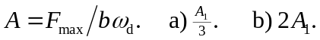 Note that the resonance frequency is independent of the value of b (see Fig. (13.27)).

